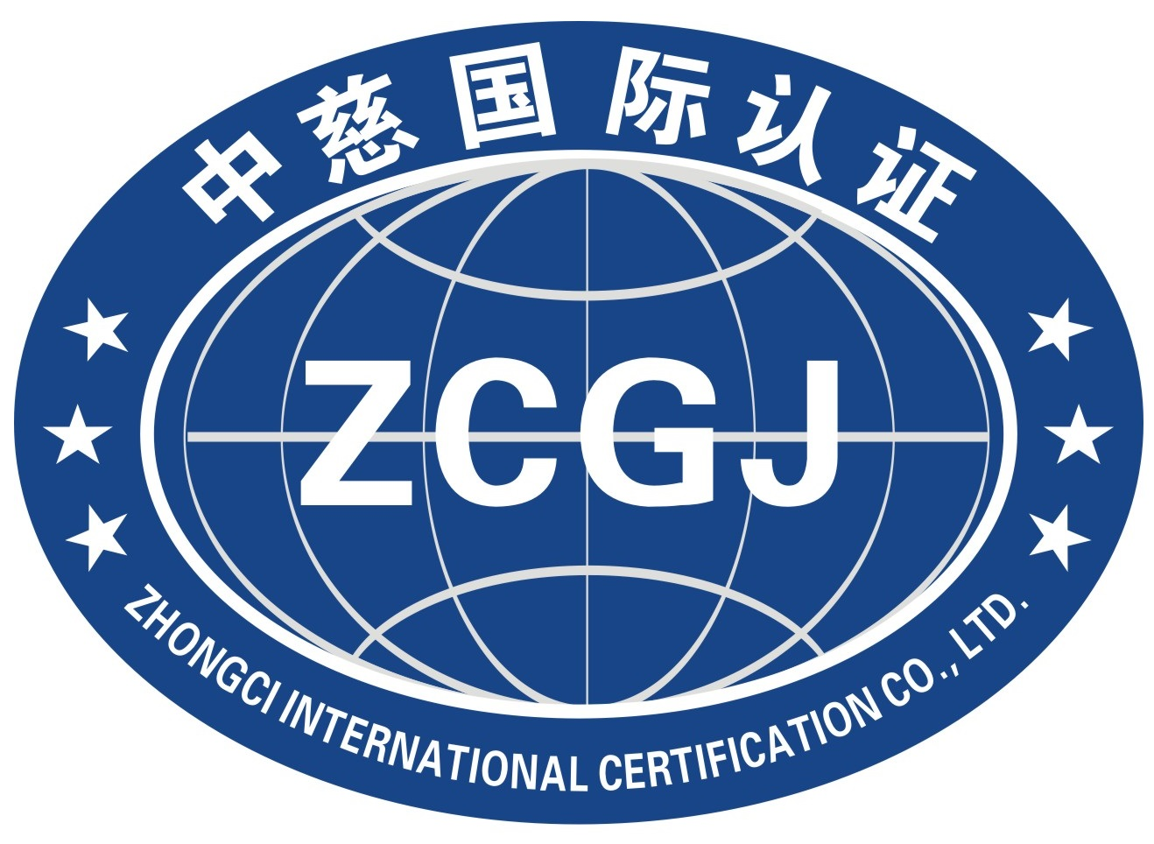

中慈国际认证有限公司
Zhongci International Certification Co., Ltd.

认证合同书
Certification contract

申请认证组织名称：
Name of organization applying for certification：

甲方（申请认证组织）：
Party A（Organization applying for certification）：
联系人Contact person： 电话Tel.： 传真Fax：
联系地址Contact address： 邮编Zip code：

乙方（审核方/发证方）： 中慈国际认证有限公司
Party B（Reviewer / Issuer）： Zhongci International Certification Co., Ltd.
联系人Contact person：陈 敏 电话Tel.：0574-63520088 传真Fax：0574-63071808
联系地址/邮编Contact address / Zip code： 浙江省宁波杭州湾新区滨海二路77号16号楼<1-3> / 315336

就有关认证事宜，经甲乙双方协商一致，在甲方向乙方提交《管理体系/服务认证申请书》并经乙方合同评审后，签订合同如下：
The following contract is signed after Party A submits the application for management system / service certification to Party B and Party B reviews the contract:
一．认证依据及范围 Certification basis and scope：
1、认证依据Certification basis：
认证领域  Certification field | 认证类型  Certification Type | 认证依据标准  Certification basis standard
质量管理体系  Quality management system | □初审 Preliminary review  □再认证 Recertification  □其他Others | GB/T 19001-2016/  ISO 9001:2015
工程建设施工企业质量管理规范  Code for quality management of Engineering Construction Enterprises | □初审 Preliminary review  □再认证 Recertification  □其他Others | GB/T 50430-2017
医疗器械质量管理体系  Medical device quality management system | □初审 Preliminary review  □再认证 Recertification  □其他Others | GB/T 42061-2022/  ISO 13485:2016
环境管理体系  Environmental management system | □初审 Preliminary review  □再认证 Recertification  □其他Others | GB/T 24001-2016/  ISO 14001:2015
职业健康安全管理体系  Occupational health and safety management system | □初审 Preliminary review  □再认证 Recertification  □其他Others | GB/T 45001-2020/  ISO 45001:2018
HSE健康、安全和环境管理体系  HSE health, safety and environment management system | □初审 Preliminary review  □再认证 Recertification  □其他Others | SY/T 6276-2014
企业社会责任管理体系  Corporate social responsibility management system | □初审 Preliminary review  □再认证 Recertification  □其他Others | □SA 8000:2014  □GB/T 39604-2020
供应链安全管理体系  Supply chain security management system | □初审 Preliminary review  □再认证 Recertification  □其他Others | ISO 28000:2022
企业诚信管理体系  Enterprise integrity management system | □初审 Preliminary review  □再认证 Recertification  □其他Others | GB/T 31950-2023
培训体系  Training system | □初审 Preliminary review  □再认证 Recertification  □其他Others | GB/T19025-2001/  ISO10015:1999
有害物质过程管理体系  Hazardous substance process management system | □初审 Preliminary review  □再认证 Recertification  □其他Others | IECQ QC080000:2017
履约能力评价体系-企业质量信用评价指标Performance evaluation system - enterprise quality credit evaluation index | □初审 Preliminary review  □再认证 Recertification  □其他Others | GB/T 31863-2015
履约能力评价体系-企业合同信用指标指南Performance capability evaluation system - A Guide to enterprise contract credit indicators | □初审 Preliminary review  □再认证 Recertification  □其他Others | GB/T 33718-2017
合规管理体系  Compliance management system | □初审 Preliminary review  □再认证 Recertification  □其他Others | GB/T35770-2022/  ISO 37301:2021
设备管理体系  Facility management system | □初审 Preliminary review  □再认证 Recertification  □其他Others | □ISO 41001:2018  □T/CAPE 10001-2017
知识管理体系  Knowledge management system | □初审 Preliminary review  □再认证 Recertification  □其他Others | ISO 30401:2018
信用管理体系  Credit management system | □初审 Preliminary review  □再认证 Recertification  □其他Others | IB/T ICS9001-2015
资产管理体系  Asset management system | □初审 Preliminary review  □再认证 Recertification  □其他Others | GB/T 33173-2016/  ISO 55001:2014
文件管理体系  Document management system | □初审 Preliminary review  □再认证 Recertification  □其他Others | GB/T 34112-2022/  ISO 30301:2019
企业标准化管理体系  Enterprise standardized management system | □初审 Preliminary review  □再认证 Recertification  □其他Others | GB/T 15496-2017
清洁生产管理体系  Clean production management system | □初审 Preliminary review  □再认证 Recertification  □其他Others | T/CACE 009-2017
商品售后服务评价体系  Commodity after-sales service evaluation system | □初审 Preliminary review  □再认证 Recertification  □其他Others | GB/T 27922-2011

2、认证范围Scope of certification：
认证所覆盖的产品/服务范围Scope of products / Services covered by certification：

（最终以审核组长在审核现场确认的产品/服务为准Finally, the products / Services confirmed by the audit team leader at the audit site shall prevail）；
生产地址Manufacturing address：
经营地址Business address：

二、甲方责任及义务 Responsibilities and obligations of Party A：
1、遵守国家法律法规和认证认可相关法律法规规定Comply with national laws and regulations and relevant laws and regulations on certification and accreditation；
2、获得认证后持续有效运行管理体系Continuously and effectively operate the management system after obtaining the certification；
3、按乙方要求提交本组织有效版本的必要的体系有关文件化信息Submit the necessary system related documented information of the effective version of the organization as required by Party B；
4、认证审核（如第一阶段审核、初审、现场验证、监督审核及再认证）期间，乙方派出的审核组人员的食、宿、交通费用按实际发生额由甲方承担；适用时，为到场的观察员（如认可评审员或实习审核员）提供条件During the certification audit (such as the first stage audit, preliminary audit, on-site verification, supervision audit and re certification), the food, accommodation and transportation expenses of the audit team sent by Party B shall be borne by Party A according to the actual amount;Where applicable, provide conditions for observers present (such as recognized reviewers or trainee auditors)；
5、在审核中发现的不符合项，甲方应在规定期限内完成原因分析、纠正和制定纠正措施并提交乙方以便及时完成有效性的验证，否则可能引起的认证注册的损失将由甲方自行承担In case of any nonconformity found in the audit, Party A shall complete the cause analysis, correction and formulate corrective measures within the specified time limit and submit them to Party B for timely verification of effectiveness, otherwise the loss of certification registration may be borne by Party A；
6、协助认证监管部门的监督检查，对有关事项的询问和调查如实提供相关材料和信息，并承担信息不准或不真实产生的一切后果Assist the supervision and inspection of the certification supervision department, truthfully provide relevant materials and information for the inquiry and investigation of relevant matters, and bear all the consequences of inaccurate or untrue information；
7、在获准认证的范围内说明获证资格，在宣传认证结果时，不得损害乙方声誉，不得作出使乙方认为误导或未授权的声明Explain the qualification within the scope of the approved certification. When publicizing the certification results, it shall not damage Party B's reputation or make statements that make Party B think misleading or unauthorized；
8、对获证范围的管理体系运行的有效性和出现违反法规的相应事故负责Be responsible for the effectiveness of the operation of the management system within the scope of certification and the corresponding accidents in violation of laws and regulations；
9、按国家有关认证的规定接受监督审核，并按时交纳相关费用Accept supervision and audit according to relevant national certification regulations, and pay relevant fees on time；
10、获证后正确使用认证证书、认证标识（牌）和有关信息；不擅自利用管理体系认证证书和相关文字、符号误导公众认为其产品或服务通过认证correctly use the certification certificate, certification mark (plate) and relevant information after obtaining the certificate;Do not use the management system certification certificate and relevant words and symbols to mislead the public that its products or services have passed the certification；
11、当甲方接到暂停/注销/撤销认证通知时，应立即停止涉及认证内容的广告及相关宣传活动，停止认证证书和认证标识的使用；立即交还认证证书。由于甲方继续使用认证证书及标识所带来的责任由甲方承担When Party A receives the notice of suspension / cancellation / revocation of certification, it shall immediately stop the advertising and related publicity activities related to certification content, and stop the use of certification certificate and certification mark;Return the certificate immediately.Party A shall bear the responsibilities arising from Party A&apos;s continued use of the certification certificate and logo；
12、获证后发生以下情况时，及时向认证机构通报After obtaining the certificate, the following situations shall be reported to the certification authority in time；
1) 客户及相关方有重大投诉Major complaints from customers and interested parties；
2）生产、销售的产品或提供的服务被质量或市场监管部门认定为不合格或处罚；被环保/安全部门认定为不合格或处罚The products produced and sold or the services provided are identified as unqualified or punished by the quality or market supervision department;Be identified as unqualified or punished by the environmental protection / safety department；
3）发生产品和服务的质量/环境/安全事故Quality / environment / safety accidents of products and services；
4）相关情况发生变更，包括：法律地位、生产经营状况、组织状态或所有权变更；取得的行政许可资格、强制性认证或其他资质证书变更；法定代表人、最高管理者变更；生产经营或服务的工作场所变更；管理体系覆盖的活动范围变更；管理体系和重要过程的重大变更等Changes in relevant circumstances, including changes in legal status, production and operation status, organizational status or ownership;Change of administrative license qualification, compulsory certification or other qualification certificates obtained;Change of legal representative and top management;Change of workplace for production, operation or service;Changes in the scope of activities covered by the management system;Major changes in management system and important processes, etc.；
5）出现影响管理体系运行的其他重要情况Other important situations affecting the operation of the management system.
13、获证组织发生重大变更但未通报乙方或通报不及时、不属实，导致认证证书没有及时变更，而认证组织仍在使用原认证证书，由此引发的法律责任由甲方承担 If the certified organization has a major change but fails to notify Party B or the notification is not timely and untrue, resulting in the failure to change the certification certificate in time, but the certification organization is still using the original certification certificate, the legal liability arising therefrom shall be borne by Party A.

三、乙方责任及义务 Responsibilities and obligations of Party B：
1、遵守国家法律法规和认证认可相关法律法规规定Comply with national laws and regulations and relevant laws and regulations on certification and accreditation；
2、以标准为依据，严格依照程序开展认证工作 Carry out certification work in strict accordance with procedures based on standards；
3、认证审核中涉及甲方保密的内容，未经甲方书面允许，保证不外泄；但下列情况除外The contents involved in Party A&apos;s confidentiality in the certification audit shall not be disclosed without the written permission of Party A;Except for the following circumstances：
1）甲方已经公开的资料Materials already disclosed by Party A；
2）法律另有要求时Where otherwise required by law；
3）国家主管部门有要求时When required by the national competent department.。
4、负责将其认证要求的任何变更通知获证客户 Be responsible for notifying the certified customer of any change in its certification requirements；
5、对其所颁发的认证证书的有效性负责，提供证书有效性查询的途径和方式Be responsible for the validity of the certification certificate issued by it, and provide the ways and means of querying the validity of the certificate。

四、认证费用及付款方式 Certification fee and payment method：
（一）初审认证费用Preliminary certification fee：
1、申请费 Application fee：￥1000.00元（壹仟元整One thousand yuan only）× 个体系System；
2、审定与注册费Approval and registration fee：￥2000.00元（贰仟元整Two thousand yuan only）× 个体系System；
3、审核费Audit fee：￥ 元Yuan（大写Capitalize ）；
以上费用合计Total of the above expenses：￥ 元Yuan（大写Capitalize ），在合同生效后 7 天内，甲方向乙方支付合同总费用的50 %； 审核结束前付清所有费用Party A shall pay 50% of the total contract expenses to Party B within 7 days after the contract takes effect;All fees shall be paid before the end of the audit。

（二）每次监督审核费用Cost of each supervision and audit：
1、年 金Annuity：￥2000.00 元（贰仟元整Two thousand yuan only）× 个体系System；
2、审核费Audit fee：￥ 元Yuan（大写Capitalize ）；
以上费用合计Total of the above expenses：￥ 元Yuan（大写Capitalize ），在监督审核前30天内付清所有费用all expenses shall be paid within 30 days before the supervision and audit。

（三）每次再认证费用Cost per recertification：
1、申请费Cost per recertification：￥1000.00元（壹仟元整One thousand yuan only）× 个体系System；
2、审定与注册费Approval and registration fee：￥2000.00元Yuan（贰仟元整Two thousand yuan only）× 个体系System；
3、审核费Audit fee：￥ 元Yuan（大写Capitalize ）；
以上费用合计Total of the above expenses：￥ 元Yuan（大写Capitalize ），在再认证审核前30天付清所有费用and all fees shall be paid 30 days before the re certification audit。

（四）其他费用Other expenses：
1、审核组为甲方提供现场审核服务所发生的食宿、交通费用由甲方承担（除非另有约定）The board, lodging and transportation expenses incurred by the audit team in providing on-site audit services for Party A shall be borne by Party A (unless otherwise agreed)；
2、合同签订之日起至未实施现场审核之前，由于甲方原因造成审核终止时，甲方应按当次认证费用的50%支付；已开始实施现场审核（含初访、一阶段），由于甲方原因造成审核终止，或乙方作出认证结论为“不予通过”等情况时，甲方应按当次认证费用的100%支付并承担已经发生的差旅费用Party A shall pay 50% of the current certification fee when the audit is terminated due to Party A from the date of signing the contract until the on-site audit is not implemented;If the on-site audit (including the first visit and the first stage) has been started, the audit is terminated due to Party A, or Party B makes the certification conclusion as "fail", Party A shall pay 100% of the current certification fee and bear the travel expenses incurred；
3、甲方应按双方约定的时间和数额向乙方缴纳相关认证费用，如发生不能按时按数额缴纳认证费用时，乙方有权自发生之日起按照总认证费用的5‰每天收取甲方滞纳金Party A shall pay relevant certification fees to Party B according to the time and amount agreed by both parties. In case of failure to pay the certification fees according to the amount on time, Party B has the right to charge Party A overdue fine at 5 ‰ of the total certification fee every day from the date of occurrence；
4、甲方委托乙方制作标牌、认证证书副本、换发证书等情况时，需另外付费，费用另行按乙方规定执行When Party A entrusts Party B to make signs, copies of certification certificates, renewal certificates, etc., Party A shall pay additional fees, and the fees shall be subject to the provisions of Party B。

（五）付款方式Payment method：
甲方履行认证合同，向乙方付款，汇款帐号Party A shall perform the certification contract and pay to Party B. the remittance account number is：
开户银行Bank of deposit：宁波银行慈溪中心区支行；
户 名Account name：中慈国际认证有限公司；
帐 号Account number：6203 0122 0006 51088

五、说明Description：
1、现场审核的具体时间由双方协商确定The specific time of on-site audit shall be determined by both parties through negotiation；
2、如果现场审核时出现因填报人数与实际人数相差较大，而需增加审核人日数和相关费用时，甲方有责任予以满足，以3000 元/人日的收费标准，按实际发生的审核人日计算费用If there is a large difference between the number of people filled in and the actual number of people during on-site audit, and it is necessary to increase the number of reviewer days and relevant expenses, Party A shall be responsible for meeting them, and the expenses shall be calculated according to the actual reviewer days at the charging standard of 3000 yuan / person day；
3、乙方仅在获得相应认可机构认可的业务范围内颁发带其认可标识的认证证书Party B shall only issue the certificate with its approval mark within the business scope approved by the corresponding approval institution；
4、本合同一式 贰 份，自双方签章之日起生效，甲方持 壹 份，乙方持 壹 份，具有同等的法律效力。合同执行中的未尽事宜，经双方协商一致后，签订补充协议This contract is made in duplicate and takes effect from the date of signature and seal by both parties. Party A holds one copy and Party B holds one copy, which has the same legal effect.For matters not covered in the execution of the contract, a supplementary agreement shall be signed after both parties reach an agreement through consultation；
5、本合同自签定之日起至获证后三年为一个有效期满，到期双方未提出异议，本合同自动延续The contract shall be valid for three years from the date of signing to the date of obtaining the certificate. If no objection is raised by both parties at the expiration, the contract shall be automatically renewed；
6、甲乙双方必须认真执行合同，如签订合同后一方不能履行合同时，双方协商解决，由于终止合同所产生的经济损失由责任方承担Party A and Party B must earnestly execute the contract. If one party fails to perform the contract after signing the contract, both parties shall settle it through negotiation. The economic losses caused by the termination of the contract shall be borne by the responsible party；
7、本合同所有条款均应满足中华人民共和国的法律、法规要求，因本合同所发生的争议，甲乙双方协商解决；如不能达成协议，双方约定向乙方所在地人民法院提起诉讼All terms of this contract shall meet the requirements of laws and regulations of the people&apos;s Republic of China. Disputes arising from this contract shall be settled by both parties through negotiation;If no agreement can be reached, both parties agree to bring a lawsuit to the people&apos;s court where Party B is located。
以下无正文There is no text following！

甲方代表签字：  Signature of Party A&apos;s representative： | 乙方代表签字：  Signature of Party B&apos;s representative：
单位公章Official seal： | 单位公章Official seal：
年Year 月Month 日Date | 年Year 月Month 日Date

